**5:** **Cursor and Exceptions in PL/SQL**

1. Government is promoting women employees in your organization. Enlist name of all female employees using **cursor** in PL/SQL.

Solution:

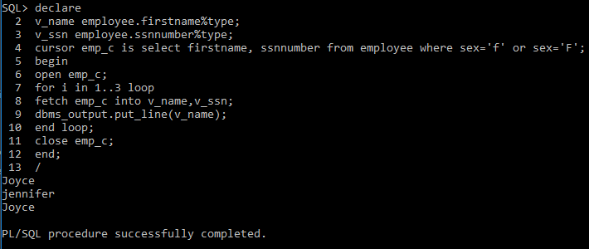

1. Using **curser**, display name and contact number of all male employees. Also, give the total number of outputs you get.

Solution:

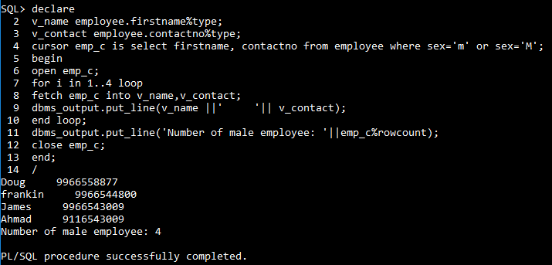

1. Create a PL/SQL program using **Cursors** to print the ssn, salary, manager name, and the department name of an employee from his firstname and lastname as input.

Solution: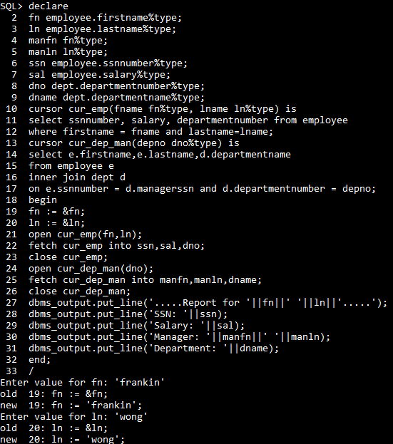

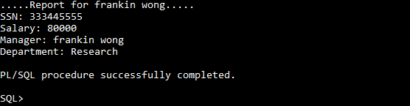

1. The update clause in the **cursor** query locks the affected rows when the cursor is opened. Using this, update employee relation for two employees, Doug and Joy.

Solution:

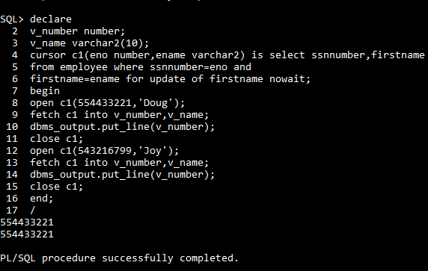

1. Using **cursor** in PL/SQL find total number of female employees of your organization.

Solution:

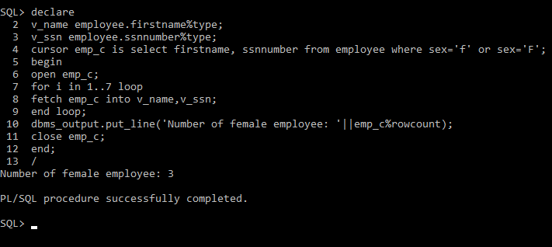

1. Write a PL/SQL block using **cursor** to display number of employees for each department.

Solution:

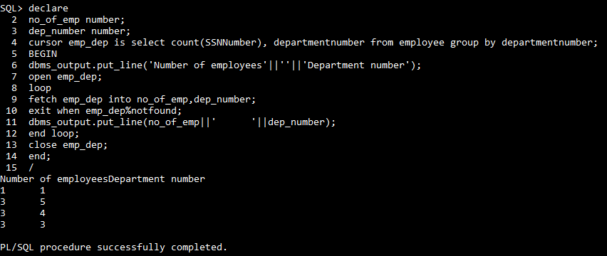

1. Create a PL/SQL program using **cursor** to output the number of people working on a given project name and the total investment into that project along with the per-employee investment ratio.

Solution:

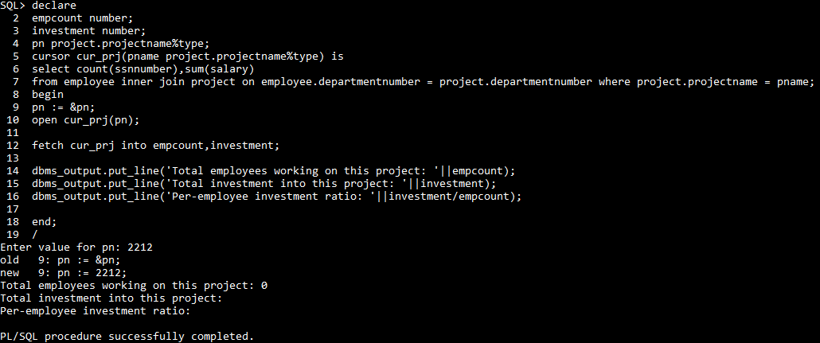

1. Write a PL/SQL program using **cursor** to delete employee details who are having age >60.

Solution:

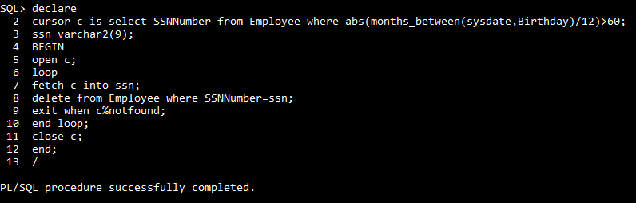

1. Add an exception using PL/SQL to **avoid division by zero**.

Solution:

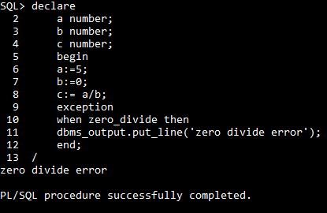

1. Display the first and last name of all employees along with their salaries using **Cursors**.

Solution:

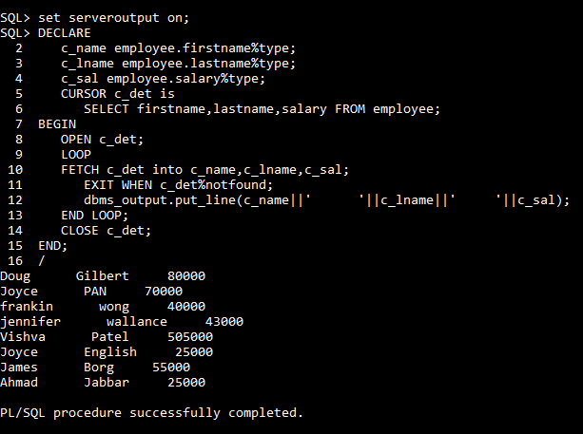

1. Define a **cursor** to update the salaries of all employees by 5000.

Solution:

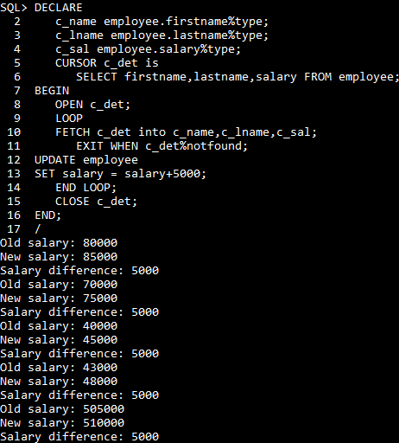

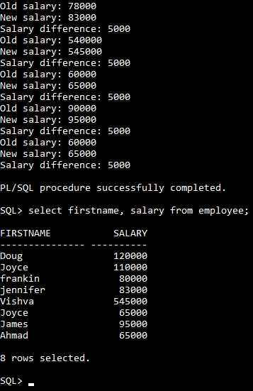

1. Write a PL/SQL block using **cursor** to display employees who are top three earners in the company.

Solution:

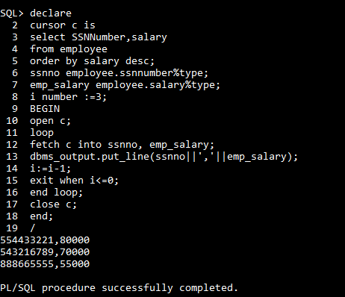

1. Define and use a **cursor** to display all department location for department number 4.

Solution:

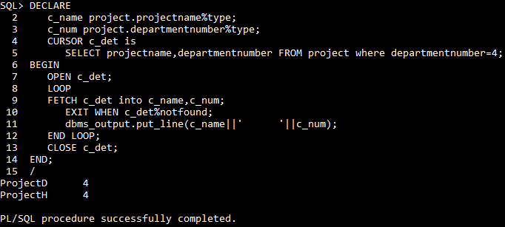

1. Create a PL/SQL program to delete those projects that do not have any employees associated with them using project number as input. If there are employees, **handle the exception** by printing an appropriate message.

Solution: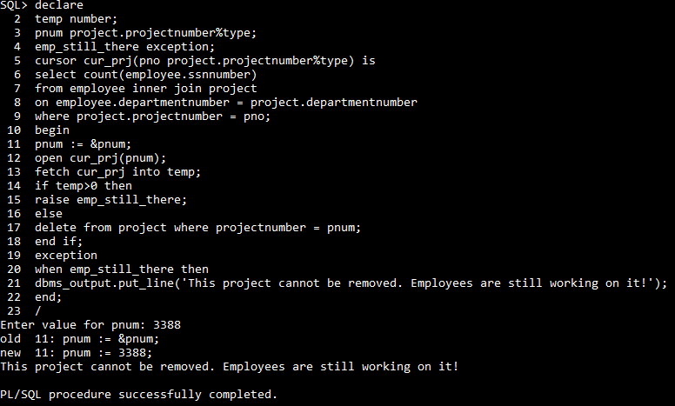

1. Define a **cursor** to group employees according to their departments by avoiding **exceptions**.

Solution:

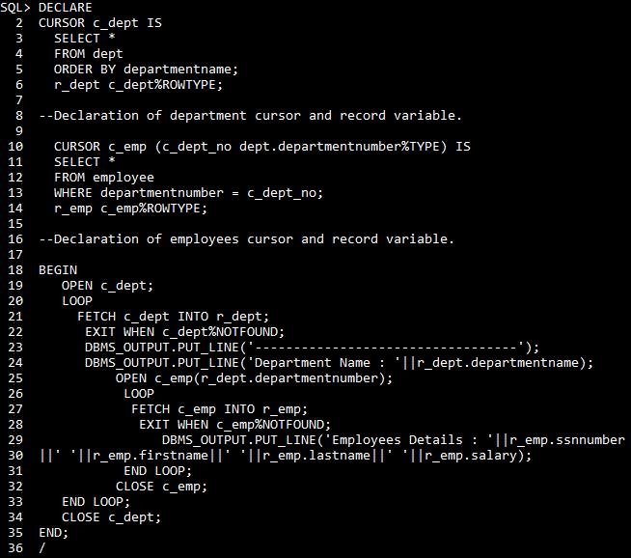

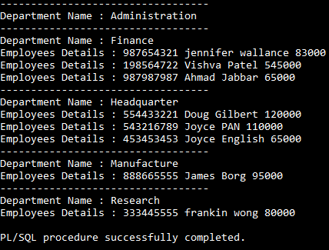

1. Using **cursor**, display the complete details of six Projects of your company.

Solution:

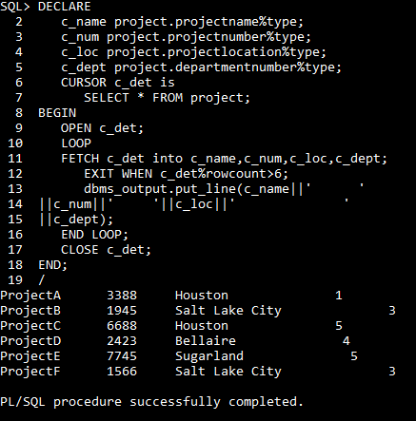

1. Use a **cursor** FOR loop to display the last names of all employees in department 4.

Solution:

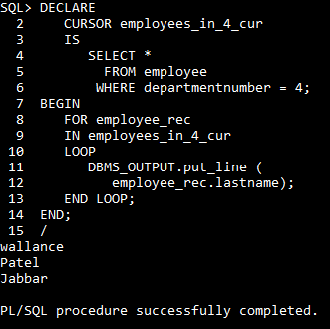

1. Write a PL/SQL code using **cursor** to print the employee’s cadre based on their basic scales as given below.

|  |
| --- |
| Basic Scale Cadre |
| 45000 Manager |
| 35000 Supervisor |
| 25000 Worker |

Improve your query using **exception handling.**

Solution:

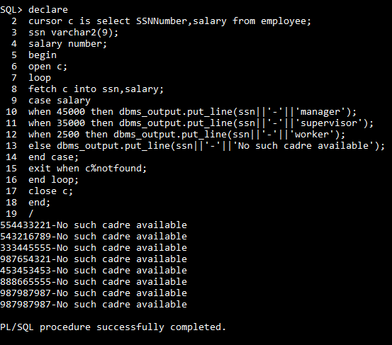

1. Use a **cursor** to display the SSN number of all male employees.

Solution:

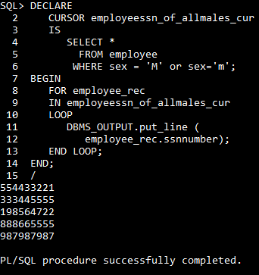

1. Write a **cursor** program to display manager details for manufacture department.

Solution:

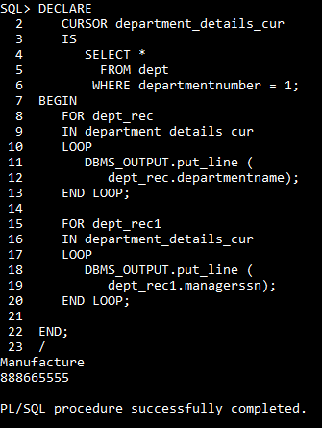

1. Display a message of invalid department number if the entered department number for deletion in employee table is incorrect using **exception handling**.

Solution:

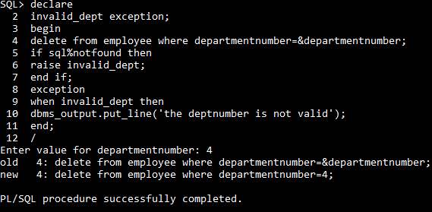

1. Create a PL/SQL program using **Cursor** to take some salary amount as input from the user and print out the names of people having lesser salary than the input amount.

Solution:

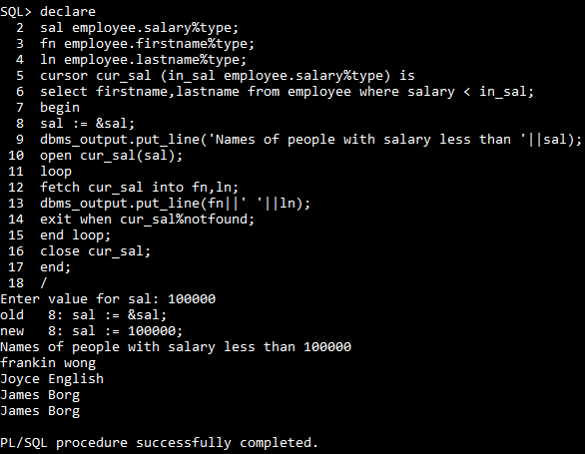

1. Find the total number of projects in Project Table using **cursors**.

Solution:

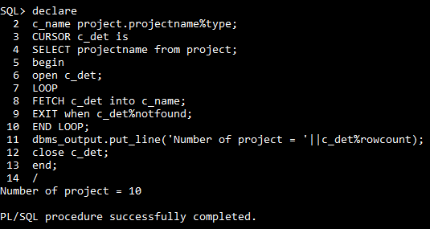

1. Create an **exception** to identify if salary of employee is less than 80000.

Solution:



